Data Operations - Create

Definition
# Source: AI Source: Provided by: [Data Path: Persons Table -> ID Column: 1, Name_En Column: Motasem Essam] -> From: [Chatgpt (GPT‑5 Mini)] on [12/10/2025]
Create is the process of generating new datasets, tables, or files in a storage system or database.
- It allows users to organize data in a new structure for storage, retrieval, or analysis.
Key idea:
It’s like starting a new filing cabinet or notebook to store information that did not exist before.

Characteristics of Create
# Source: AI Source: Provided by: [Data Path: Persons Table -> ID Column: 1, Name_En Column: Motasem Essam] -> From: [Chatgpt (GPT‑5 Mini)] on [12/10/2025]
- Generates new storage objects (tables, files, or datasets)
- Can be structured (tables in databases) or unstructured (text or CSV files)
- Supports future insertion, retrieval, and analysis
- Often done using database commands, software tools, or programming scripts
- Lays the foundation for all subsequent data operations

Example
# Source: AI Source: Provided by: [Data Path: Persons Table -> ID Column: 1, Name_En Column: Motasem Essam] -> From: [Chatgpt (GPT‑5 Mini)] on [12/10/2025]
Creating a new student table in a database:
- SQL Query:
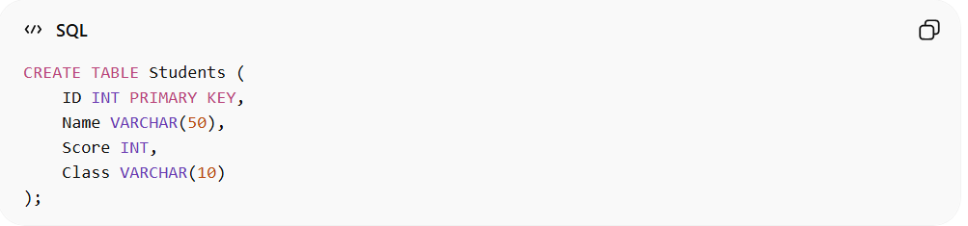
CREATE TABLE Students (
ID INT PRIMARY KEY,
Name VARCHAR(50),
Score INT,
Class VARCHAR(10)
);
Result: A new empty table Students is created, ready to store student records:
ID | Name | Score | Class

Example Section
# Source: AI Source: Provided by: [Data Path: Persons Table -> ID Column: 1, Name_En Column: Motasem Essam] -> From: [Chatgpt (GPT‑5 Mini)] on [12/10/2025]
A school wants to store test results for a new class:
- The administrator creates a new table called Class10B_Students.
- Once created, they can insert student records and perform retrieval, sorting, filtering, and updates.

Advantages
# Source: AI Source: Provided by: [Data Path: Persons Table -> ID Column: 1, Name_En Column: Motasem Essam] -> From: [Chatgpt (GPT‑5 Mini)] on [12/10/2025]
- Provides a new structure for storing data
- Enables organized data management from the start
- Essential for database-driven systems and large datasets
- Forms the foundation for insertion, retrieval, and updates

Disadvantages
# Source: AI Source: Provided by: [Data Path: Persons Table -> ID Column: 1, Name_En Column: Motasem Essam] -> From: [Chatgpt (GPT‑5 Mini)] on [12/10/2025]
- Poor design during creation may lead to inefficient data structure
- Changing the structure later can be time-consuming and complex
- May require technical knowledge (SQL, database design)
- Incorrect configuration can cause data redundancy or inconsistency

